Tutorial 3: Test Driven Development
Test Driven Development (TDD) is an approach to software development combining test-first development and refactoring. In other words, you write a test before you write just enough coding to fulfil that test. The steps of test-first development are shown below:
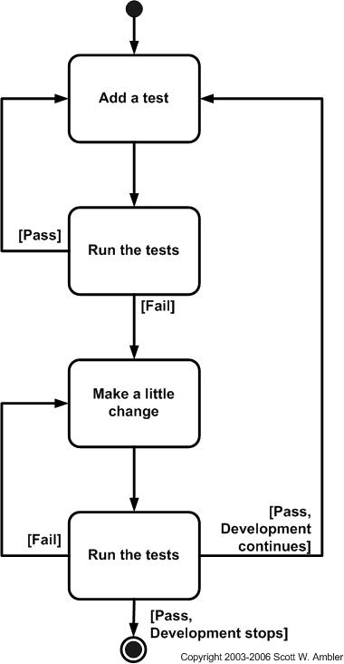

For installation and setup of Python, refer to the link below:
https://realpython.com/installing-python/
Read more about testing in Python in the link below:
https://realpython.com/python-testing/#writing-your-first-test

Learning TDD with unit testing tool in Python
In this example, we will program a simple calculator using python and TDD. We will create two python files. The first is the test file and the second is the file that contains the actual program.
To start, we will write a test file with the filename test_Calculator.py. To be consistent, it is good to start the filename with test_ to denote that this is a test file.
We add in a simple test to see if the add function of the calculator works properly as shown below:
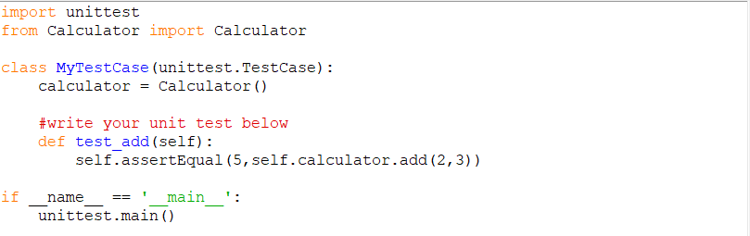
Note: These are two underscores!
Run the test file and it will fail. This is because the Calculator class is not defined yet.
Next, we create a new empty file Calculator.py with the code as shown below:
Run the test file (test_Calculator.py) again and this time you will receive a different error message AttributeError: 'Calculator' object has no attribute 'add'.
Now, we will need to create the add functionality to the Calculator. Update the Calculator.py file accordingly:
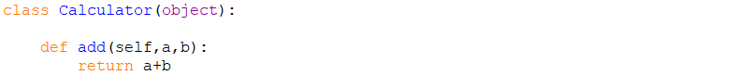
Run the test file again and this time you will see that the test has passed!
Congratulations! You have done your first TDD in python.
You can now setup more functionality such as minus. The test file below is now updated with more tests in add and minus.
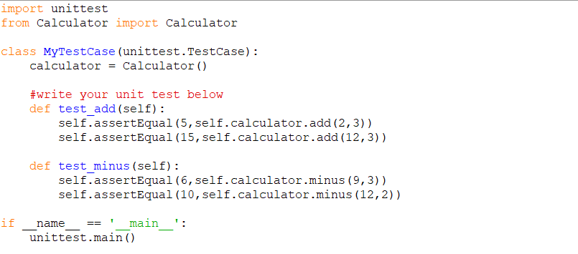
Run the test file and it will fail saying that the AttributeError: 'Calculator' object has no attribute 'minus'. Back to the Calculator.py file and update the minus functionality accordingly.
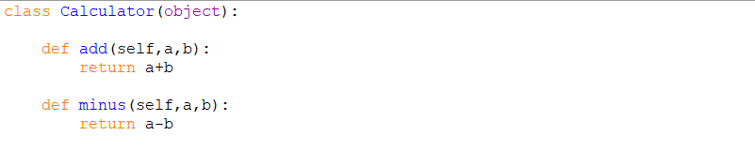
Run the test file again and you will see that all the tests would have passed. You can continue this process until you have fulfilled all the requirements for your calculator.
Task 1: Add the multiply function to your Calculator with the appropriate tests

Below are some resources you can use to learn more about TDD in Python
Python – using PyUnit
  - Web Tutorial
    - https://code.tutsplus.com/tutorials/beginning-test-driven-development-in-python--net-30137
    - https://testdriven.io/blog/modern-tdd/
  - Video Tutorial
    - https://www.youtube.com/watch?v=eJNNIyo9VEU
    - https://www.youtube.com/watch?v=6tNS--WetLI
Now that you have learnt about TDD and automated unit testing. It is now time for you to start developing a small program using what you have just learnt.

Task 2: Write a program using TDD to calculate the area of different types of figures (square, rectangle, triangle, and trapezium).

Task 3: Write a program using TDD to output the grade of a mark
Write two main test cases that checks for:
- Checking if the input is valid
- Giving the right grade based on the input mark. Grading follows the following system:
  - HD: 85 and above
  - D: 75 to 84
  - C: 65 to 74
  - P: 50 to 64
  - F: below 50

Task 4: Write a program using TDD to validate a password.
The requirements for this program are to check the user password based on the following:
- The password has to be at least 8 characters, max of 15
- At least one uppercase
- At least one lowercase
- At least one digit
- At least one symbol -_.!@#$^&()

You can also use other languages to implement TDD. Below are some resources you can use to learn about TDD. Pick one language you are familiar with and start learning TDD. You will also need to learn the appropriate unit testing tool to setup automation testing.
References for other programming language
- Java – using JUnit
  - Web Tutorial
    - https://www.cprime.com/resources/blog/unit-testing-tutorial-getting-started-with-test-driven-development-with-java/
  - Video Tutorial
    - https://www.youtube.com/watch?v=sDhPXZmAUDY
    - https://www.youtube.com/watch?v=HRxjvaKu-X4

- JavaScript – using QUnit
  - Web Tutorial
    - https://github.com/dwyl/learn-tdd
  - Video Tutorial
    - https://www.youtube.com/watch?v=-WLgrVDpI-Y
    - https://www.youtube.com/watch?v=r9HdJ8P6GQI

- .NET – using NUnit
  - Web Tutorial
    - https://www.lambdatest.com/blog/setup-nunit-environment-with-visual-studio/
    - https://docs.microsoft.com/en-us/visualstudio/test/quick-start-test-driven-development-with-test-explorer?view=vs-2019
  - Video Tutorial
    - https://www.youtube.com/watch?v=1TPZetHaZ-A
    - https://www.youtube.com/watch?v=l4xhTq4qmC0

- PHP – using PHPUnit
  - Web Tutorial
    - https://medium.com/@victorsteven/test-driven-development-tdd-with-php-phpunit-and-laravel-38712c4272e9
  - Video Tutorial
    - https://www.youtube.com/watch?v=LiyQ8bvLzIE
    - https://www.youtube.com/watch?v=0Rjsuw1ScXg

